1. Create a class named person with attributes name and age. Also create a constructor and getter methods for the attributes.

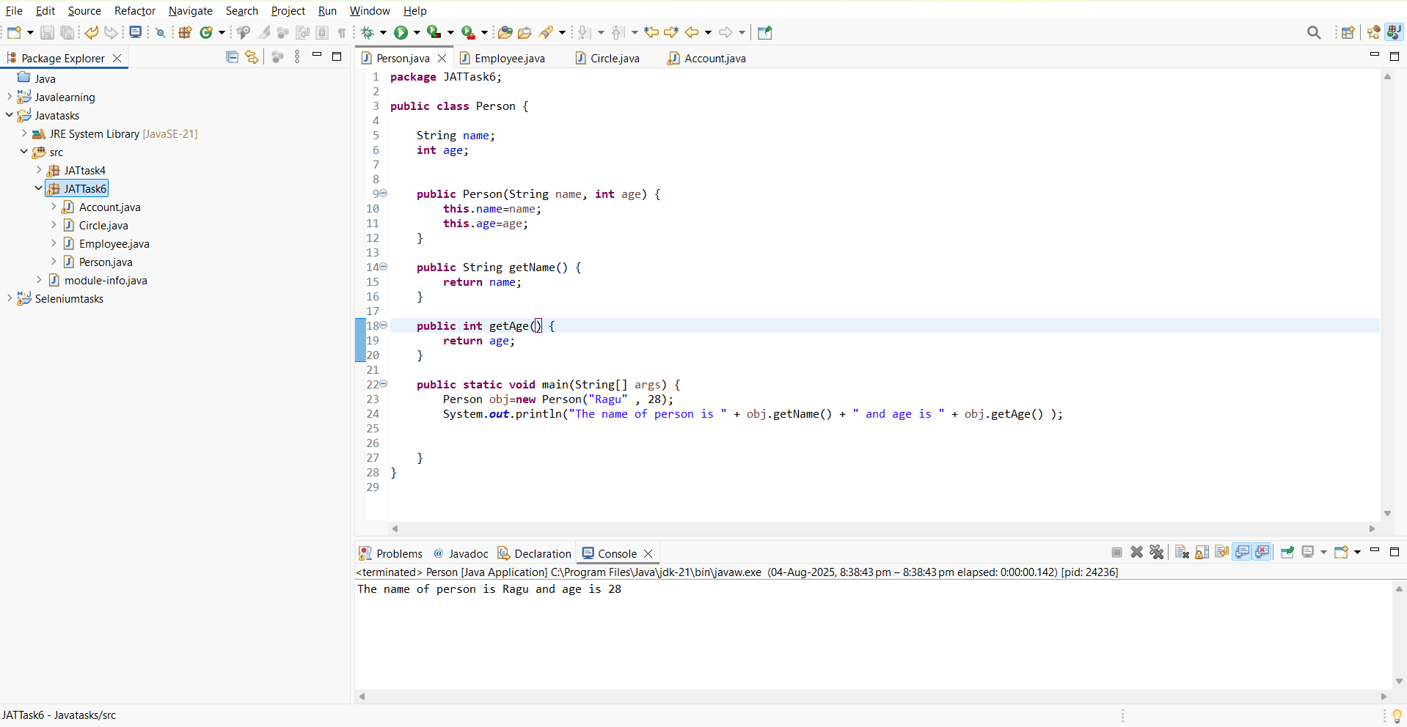

1. Create a implementation for java class names Employee

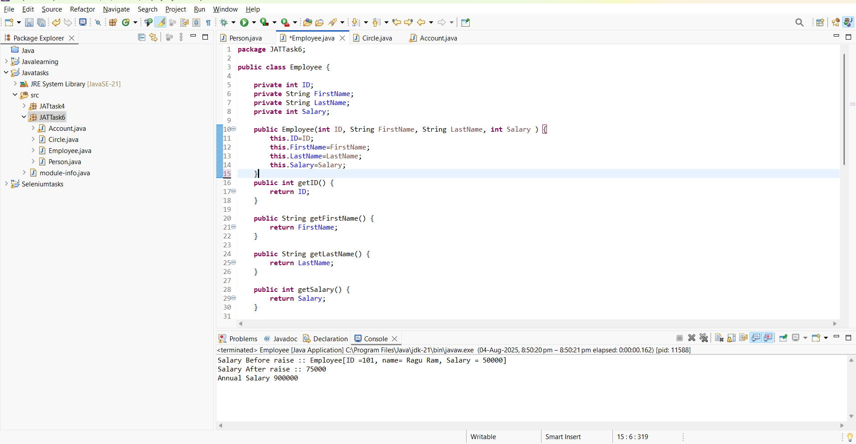

1. Create a class circle with radius as data member

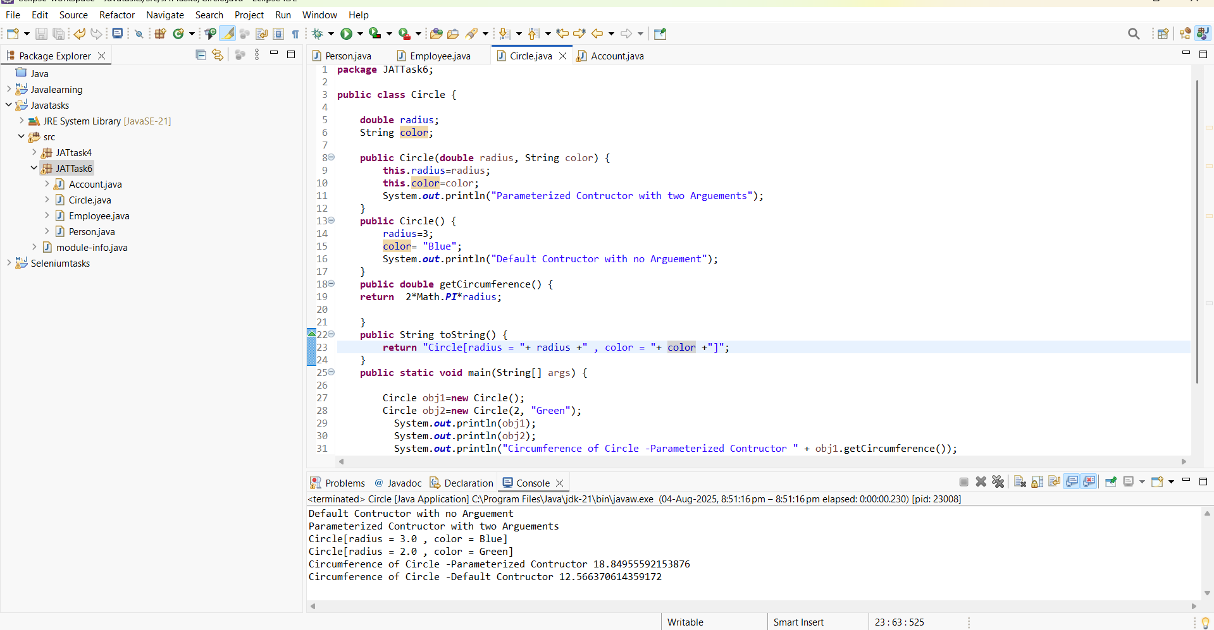

1. Class names account with 2 constructor

